H.T No
Regulations:
A19

Sreenidhi Institute of Science and Technology
(An Autonomous Institution)
Code No: 7W103 Date: 16-July-2021 (FN)

M.Tech I-Year I-Semester External Examination, July - 2021 (Regular & Supplementary)
ADVANCED MECHANICS OF SOLIDS (CADCAM)

Time: 3 Hours Max.Marks:70

Note: a) No additional answer sheets will be provided.
b) All sub-parts of a question must be answered at one place only, otherwise it will not be valued.
c) Missing data can be assumed suitably.

ANSWER ANY 5 OUT OF 8 QUESTIONS. EACH QUESTION CARRIES 14 MARKS.

Bloom's Cognitive Levels of Learning (BCLL)

Remember | L1 | Apply | L3 | Evaluate | L5
Understand | L2 | Analyze | L4 | Create | L6

 |  |  | BCLL | CO(s) | Marks
1. | a) | A cantilever is supported at the free end by an elastic spring of spring constant k. Determine the reaction at A Fig.1. The cantilever beam is uniformly loaded. The intensity of loading is W.  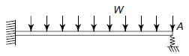  Figure 1 | L4 | CO1 | [7M]
 | b) | Explain theorem of virtual work | L5 | CO1 | [7M]
2. |  | Determine the location of shear centre for the channel section shown in the fig.2 below  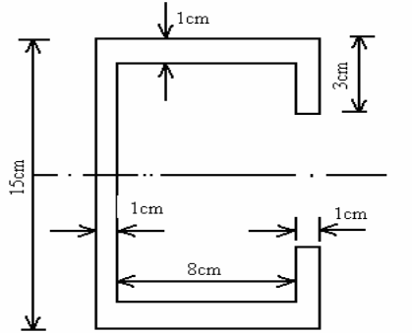  Figure. 2 | L5 | CO2 | [14M]
3. | a) | Derive Winkler-Bach formula for the given curved beam from first principles. Also sketch stress distribution across the depth of the section | L3 | CO3 | [7M]
 | b) | What is contact stress? Discuss the method of computing contact stresses. | L2 | CO3 | [7M]
4. |  | For the cross-section shown in fig.4, if stress due to torsion is limited to 35,0000 KPa, find (i) Limiting Torque, (ii) Corresponding Twist per unit length, (iii) Shear stress in web. Use G= 158 X 10⁶ kPa, t = 1.25 cm (where ever is applicable).  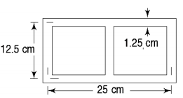 | L5 | CO4 | [14M]
5. |  | Consider a column fixed at one end and free at the other end (Fig. 3). It is subjected to a compressive load P at the free end. Determine the approximate critical load assuming the deflection curve as  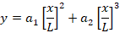  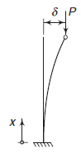  Figure. 3 | L4 | CO5 | [14M]
6. |  | Determine K_{I} and K_{II} for an inclined crack as shown in fig.4.  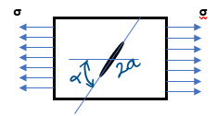  Figure.4 | L5 | CO6 | [14M]
7. |  | A feed roller (is a device used to surface – finish steel shafts) consists of two circular cylindrical steel rollers, each 200mm in diameter and arranged so that their longitudinal axes are parallel. A cylindrical steel shaft 60mm in diameter is fed between the rollers in such a manner that its longitudinal axis is perpendicular to that of the rollers. The total load P between the shaft and rollers is 4.5KN. Determine the values of the maximum principal stress and maximum shear stress in the shaft. Determine the distance from the plane of contact to the point of maximum shear stress, E= 200GPa and ν = 0.29. | L5 | CO1 | [14M]
8. | a) | A hollow aluminium section having rectangular cross section. The thickness of the section is 6 mm. Outer sides of the section having width 100 mm and height 56 mm. Find the twisting moment taken by the section and angle of twist? Modulus of rigidity is given by 28 GPa. The maximum shear stress induced is 35 N/mm² | L5 | CO4 | [7M]
 | b) | An infinitely large sheet is subjected to a gross stress of 350 MPa. There is a central crack 5/π-cm long and the material has a yield strength of 500 MPa.  i) Calculate the stress-intensity factor at the tip of the crack.  ii) Calculate the plastic–zone size at the crack tip. | L5 | CO5 | [7M]

-- 00 -- 00 –

